4.5 ANSWERS TO EXERCISES

4.5 Exercise 1

1.
a) propanoic acid b) propan-1-ol c) no reaction
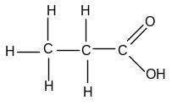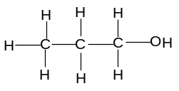

d) propan-2-ol e) 2-hydroxymethylpropanenitrile
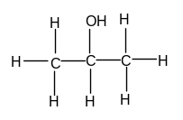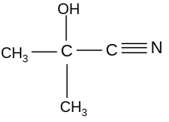

f) butanoic acid g) methylpropanoic acid h) no reaction
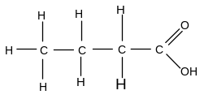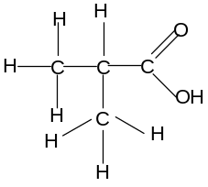

i) 2-hydroxy,2-methylbutanenitrile
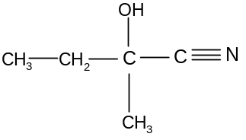

2. a) CH₃CH₂COCH₃ + 2[H] → CH₃CH₂CH(OH)CH₃
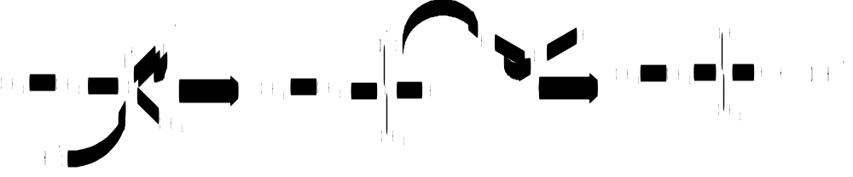
b) CH₃CH₂COCH₃ + HCN → CH₃CH₂CH(CH₃)CN
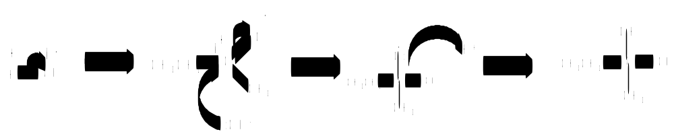
3. a) propanal and HCN b) butanone and HCN c) methylpropanal and HCN

4.5 Exercise 2

1. a) CH₃CH₂COOH + NaOH → CH₃CH₂COO⁻Na⁺ + H₂O
b) 2CH₃CH₂CH₂COOH + Na₂CO₃ → 2CH₃CH₂CH₂COO⁻Na⁺ + CO₂ + H₂O
c) HCOO⁻Na⁺ + HCl → HCOOH + NaCl
d) 2CH₃COO⁻Na⁺ + H₂SO₄ → 2CH₃COOH + Na₂SO₄
e) 2CH₃CH(CH₃)COOH + Na₂CO₃ → 2CH₃CH(CH₃)COO⁻Na⁺ + CO₂ + H₂O

2. a) CH₃CH₂COOH + CH₃OH == CH₃CH₂COOCH₃ + H₂O
organic product = methyl propanoate
b) CH₃COOH + CH₃CH(OH)CH₃ == CH₃COOCH(CH₃)CH₃ + H₂O
organic product = methylethyl ethanoate
c) HCOOH + CH₃CH₂CH₂OH == HCOOCH₂CH₂CH₃ + H₂O
organic product = propyl methanoate
d) CH₃CH₂CH₂COOH + CH₃CH₂CH₂CH₂OH == CH₃CH₂CH₂COOCH₂CH₂CH₂CH₃ + H₂O
organic product = butyl butanoate

3. a) 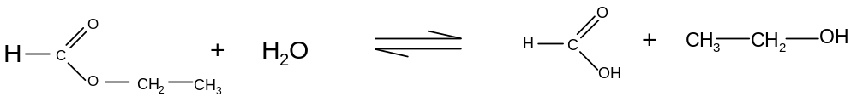b)
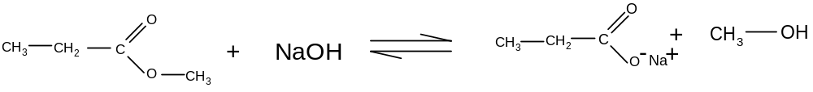c)
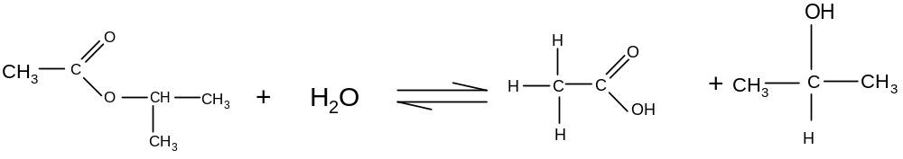
d)
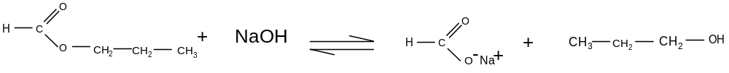

4.
a)
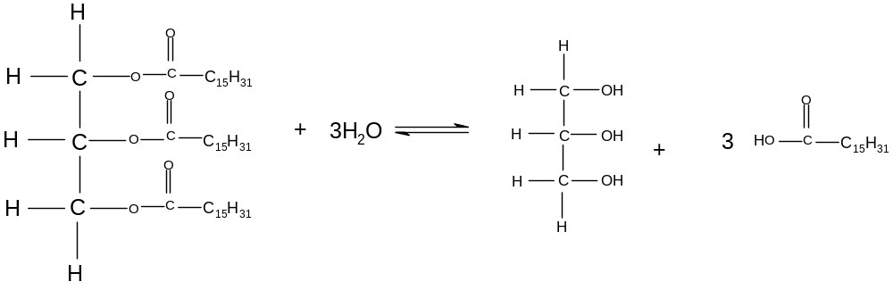

b)
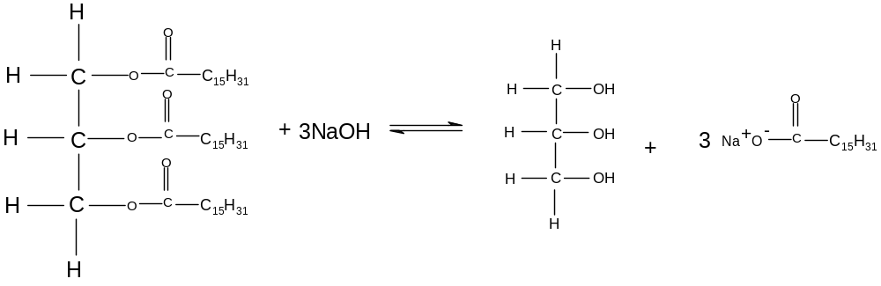
Reaction (a) takes place in the stomach
The fatty acids are used in cell membranes
The glycerol is used as an energy source
Reaction (b) is carried out industrially
The glycerol is used in pharmaceutical and cosmetic preparations
The carboxylate salts are used as soaps

4.5 Exercise 3

1. a) CH₃CH₂COCl + 2NH₃ → CH₃CH₂CONH₂ + NH₄Cl
organic product: propanamide
b) (CH₃CH₂CH₂CO)₂O + CH₃CH(OH)CH₃ → CH₃CH₂CH₂COOCH(CH₃)CH₃ + CH₃CH₂CH₂COOH
organic products: methylethyl butanoate and butanoic acid
c) HCOCl + 2CH₃CH₂NH₂ → HCONHCH₂CH₃ + CH₃CH₂NH₃⁺Cl⁻
organic product: N-ethyl methanamide
d) (CH₃CO)₂O + CH₃CH(NH₂)CH₃ → CH₃CONHCH(CH₃)CH₃ + CH₃COOH
organic products: N-methylethylethanamide and ethanoic acid
e) CH₃CH(CH₃)COCl + H₂O → CH₃CH(CH₃)COOH + HCl
organic products: methylpropanoic acid

2. a)
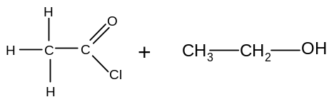
b)
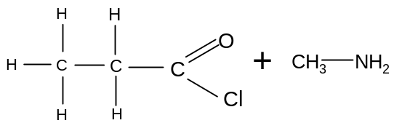
c)
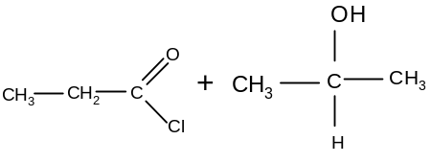
d)
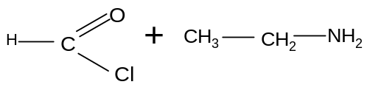
e)
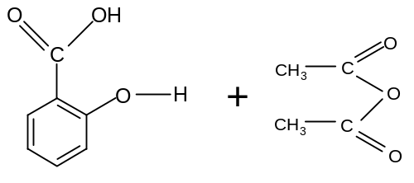
3. a)
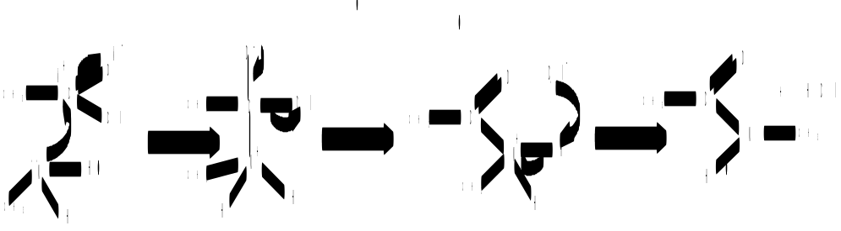
b) nucleophilic addition-elimination
c) acid anhydride is cheaper than acyl chloride
the acid anhydride reaction is less violent
the acid anhydride reaction does not produce toxic fumes of HCl

